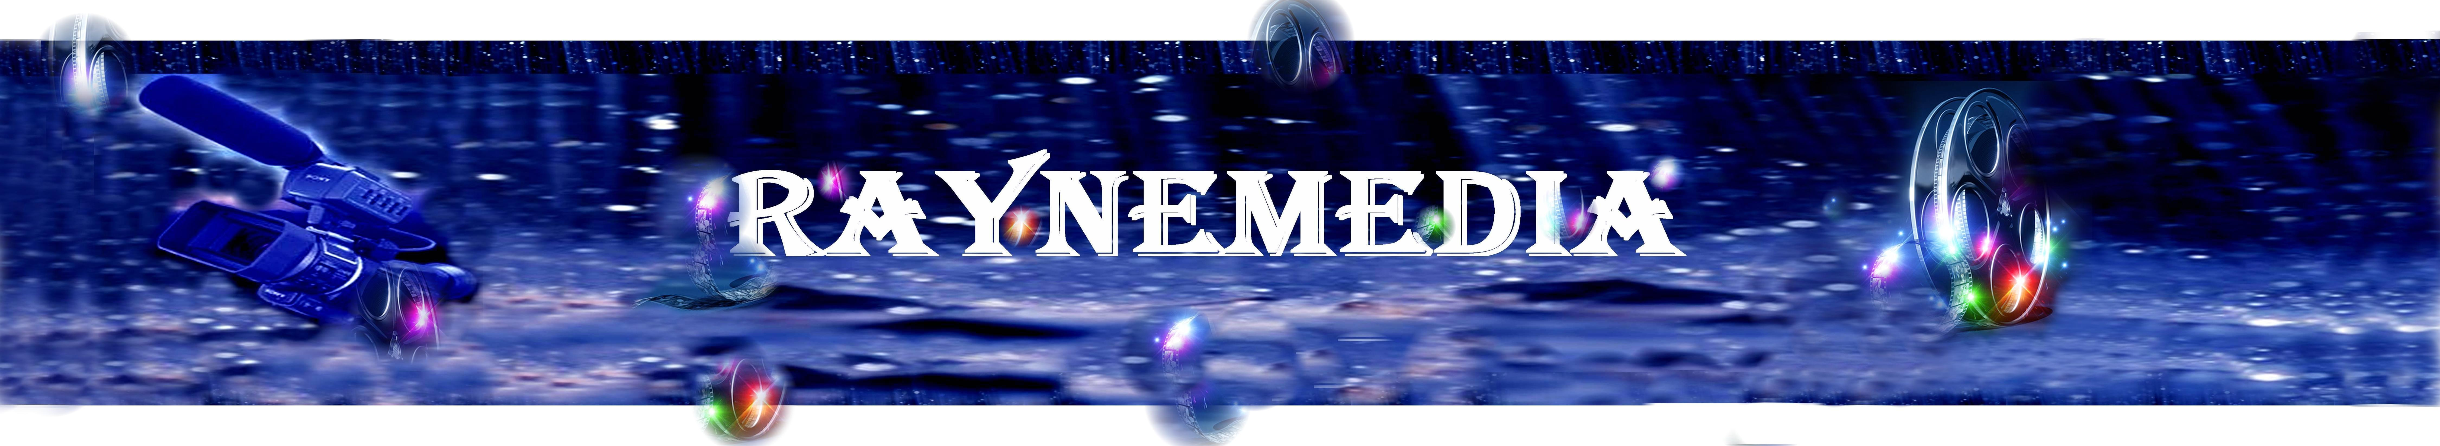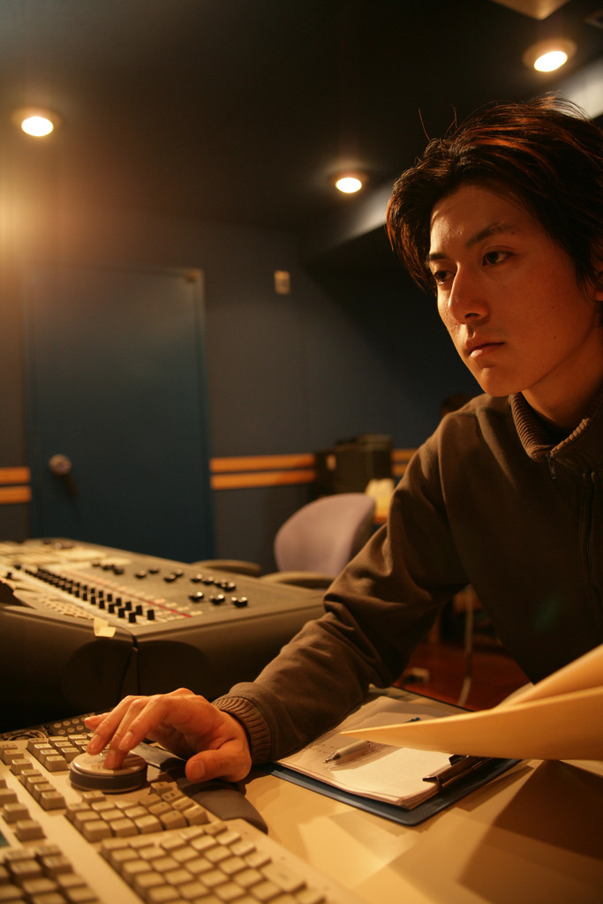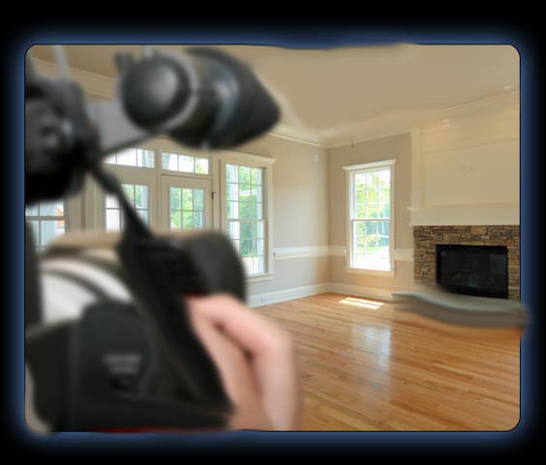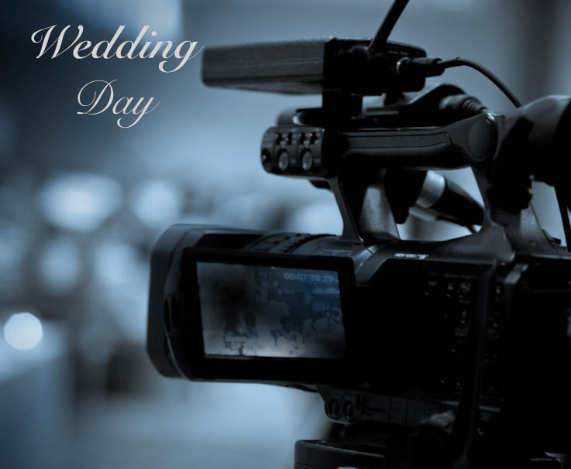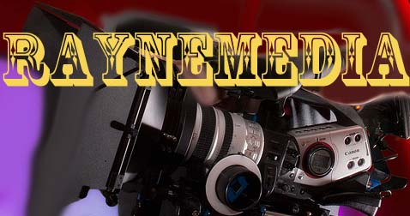

# RayneMedia Productions

* specialize in standard & HD video taping cinematography, special event, web video marketing, training video, promotional video, music videos, & corporate production, using the latest digital video equipment. (3-CCD Canon XL2 cameras & Sony HD cameras with 24p & low-level light capability).
* Our video production is finalized using Adobe, Pinnacle based editing workstations and MAC with Final Cut Pro & I Movie systems.
* We can tackle any project with our state-of-the-art cameras, high-quality microphones, and wireless systems. .
* We also provide the best professional pricing in the area.

Wedding Video , Corporate Video, Educational Video, Promotional Video, Special event Video, Training Video, Music Video, & Commercial Video services.

raynemedia@yahoo.com

404 819 7807

# Services

Ask us about our specials

137 Sterling ct  
 Alpharetta, Ga. 30004

Phone: 404 819 7807 Fax: [Fax]  
raynemedia(youtube.com)

Raynemedia

RayneMedia

Video Productions

Standard Starting Price Listing

Wedding $1200

Corporate $600

Educational $1000

Promotional $1200

Training $1000

Music Video $800

**Special promo package: $500.00**

1 Videographer

1 Standard camera

Up to 4hr at event one location.

Clean up digital editing

$50. Each additional hour.

# We offer a variety of video packages to meet your needs. The pricing of specific video packages is dependent on the complexity and length of the video.

Make every event creative

Video Media